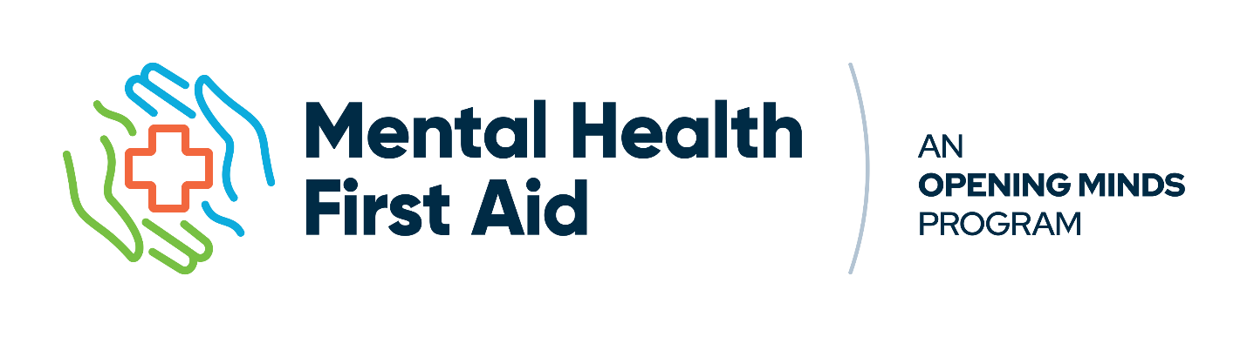
Mental Health Training For Everyone and Every One. Standard is the foundational program designed for everyone. As a globally recognized training, it empowers everyday people to recognize when someone may be experiencing mental health challenges and equips them with practical skills to provide initial support. This course builds confidence to respond calmly and offer meaningful help during tough moments—all without needing to be a mental health expert. Ideal for the general public, workplaces and community groups.
MHFA Training is now available in two streams: MHFA Essentials and MHFA Certification

MHFA Essentials is a suite of courses, focused on core knowledge and practical skills. The courses do not lead to Certification. Within the Essentials suite is a streamlined one-day course as well as adaptations to support unique populations and specific roles.
Designed to be accessible and applicable across many settings, Essentials offers a strong foundation in MHFA principles without formal assessment or certification—making it an ideal option for individuals, teams, or communities seeking meaningful, time-efficient training.
- Delivery Formats: The course is fully facilitated, with virtual and in-person options
- Course Length: 6 hours of instruction
Essentials: starts from $250 per person
MHFA Certification is an innovative and leading-edge program in the sector. Mental Health First Aid now offers official certification.
The 2-day format of the MHFA Certification allows for robust, scenario-based training on the identification and support of declining mental health and crises and provides a deeper understanding of mental health disorders and influences. Certification is to be renewed every three years.
- Delivery Formats: The course is fully facilitated, with virtual and in-person options
- Course Length: 12 hours of instruction over 2 days.
Certification: starts from $350 per person

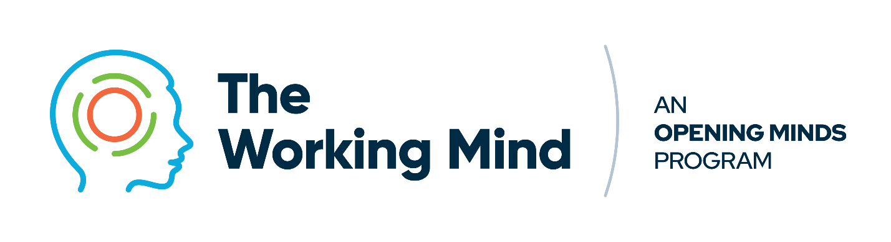
The Working Mind is a mental health course designed to drive culture change by helping people, teams, and organizations build mental health awareness and understanding, break down stigma, strengthen communication skills, and improve resilience.
The Working Mind is a mental health training program designed to imitate a change in how you think, feel, and act about Mental Health.
• Mental Health Awareness and Understanding: Recognize signs of good, declining, and poor mental health.
• Break down stigma: Cultivate a safe, supportive environment where mental health can be discussed openly and without judgment, using respectful and non-stigmatizing language.
• Strengthening communication skills: Develop a shared language to foster open dialogue about mental health between colleagues and within teams
• Improve individual resilience through practicing coping strategies in times of stress and equipping managers to support their teams with the same tools and strategies.
Key Objectives:
- Recognize signs of good, declining, and poor mental health.
- Understand mental health as a continuum.
- Understand and reduce stigma and barriers to care in the workplace.
- Engage in mental health conversations with others.
- Identify stressors and apply coping and self-care strategies.
- Support team mental health with tools and resources (managers only)

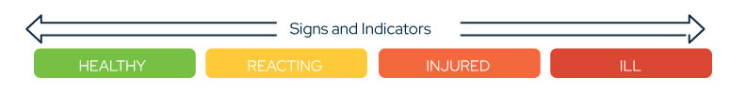

Designed for effective implementation:
- Virtual or in–person
- Cohort and team training options
- Length: 5 hours (employee)
- Length: 8 hours (manager)
- Dates and times tailored to your needs
- Scalable with in-house and external facilitator training options
Pricing Information
- Employee: From $ 200 per person
- Manager: From $ 350 per person

Facilitator Information: Georgette Reed


Georgette Reed has dedicated her life to sport, fitness, health, and mental wellness. With 50 years of competitive experience across athletics, bobsleigh, swimming, and water polo, she has transformed her passion into a career as a coach, leader, and mental health advocate.
A 17-time national champion in shot put and discus, Georgette represented Canada at the Olympic Games, World Championships, Pan American Games, and Commonwealth Games, serving as team captain at both the 1994 Commonwealth Games and the 2001 World Championships.
Following her athletic career, she spent a decade as Head Coach of Cross Country and Track & Field at the University of Alberta, where she developed champions and fostered resilience on and off the field. Today, she continues to shape Canadian sport as a mentor coach with Athletics Canada and as a national team coach at international competitions.
Georgette’s leadership extends well beyond sport. As Director of Athletics and Recreation at Capilano University, she guided the department through significant growth while prioritizing student-athlete well-being. Previously, as Health and Wellness Coordinator for Edmonton Fire Rescue Services, she advanced mental health programming for first responders, delivering training in Mental Health First Aid, Psychological First Aid, and R2MR.
Since 2013, Georgette has shared mental health literacy across Canada as a facilitator for Mental Health First Aid and The Working Mind. She also holds certifications as a Mental Health First Aid Instructor (Standard & Basic), R2MR Master Trainer, Psychological First Aid provider, ASIST Suicide Prevention Trainer, and Rainbows Crisis Support facilitator.
For more information and to book your training, contact Georgette at grcts@yahoo.ca
