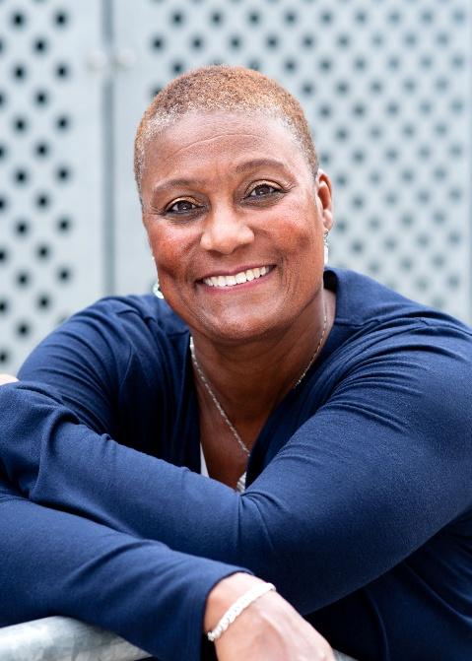
Presentations
A Plot Twist: Seizing Life’s Turning Points with Georgette
Every plot twist is a chance to shine out loud.
In this energizing talk, Georgette Reed shows how life’s unexpected turns can spark courage, healing, and renewal. With powerful insights and actionable strategies, she’ll inspire you to reframe challenges, embrace change, and transform pivotal moments into opportunities for growth and excellence.
Get ready to see your plot twists not as obstacles—but as the very moments that propel you forward.
“A Plot Twist isn’t the end—it’s the beginning.”
Caring for Others Without Losing Yourself: A Self-Care Reset with Georgette Reed
We show up for everyone else—but who’s showing up for us? Too often, in the rush to serve others, we sacrifice our own physical and mental health. In this eye-opening session, Georgette Reed challenges that cycle and offers a fresh roadmap to balance.
In this energizing session, Georgette Reed explores how to care for others without sacrificing your own well-being. With practical self-care strategies and mental health prompts, she shows how balance, resilience, and renewal can make you more effective in every role you play.
“Self-care isn’t selfish—it’s essential.”

From Burnout to Balance: Reclaim Your Energy, Focus, and Performance
Burnout isn’t subtle—it drains your body, mind, and ambition. Olympian and coach Georgette Reed shows how to spot the warning signs, reset your work-life balance, and turn stress into strength. Packed with practical strategies for mental wellness, self-care, and peak performance, this session equips you to protect your well-being and thrive—because you can’t perform at your best if you’re running on empty.
From Burnout to Balance is more than a talk—it’s a wake-up call. In this interactive session, Reed equips participants with the mindset and tools to protect their well-being, fuel their performance, and reclaim control of their lives. Because the truth is simple: you can’t perform at your best if you’re running on empty.
“Build resilience with movement and mindfulness”

Who Are You? Overcoming Imposter Syndrome and Claiming Your Power
Do you feel like a fraud, terrified that one wrong move will make you lose everything? Are you playing small just to stay safe? It’s time to stop.
Stop playing small. Georgette Reed shows you how to silence self-doubt, step into your power, and claim the unique impact only you can make. This empowering session helps you move from fear to confidence, from hesitation to bold action.
This isn’t about perfection—it’s about presence. Reed empowers you to stop shrinking, start showing up, and make your mark in the world and the communities where you live and work.
• “Imposter syndrome ends here.”
•

