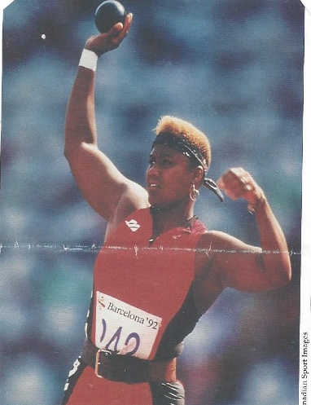

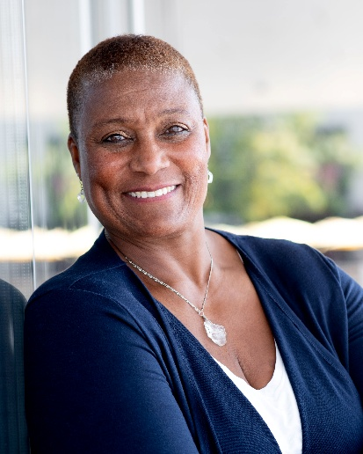
Georgette Reed is an Olympian, 17-time Canadian champion, and dynamic leader with a lifelong passion for sport, fitness, health, and wellness. A former multi-sport athlete, she competed internationally in athletics, bobsleigh, swimming, and water polo, proudly representing Canada at the Olympic Games, World Championships, Commonwealth Games, and Pan American Games. Over her remarkable career, she claimed 17 national titles—15 in the shot put and two in discus—cementing her place as one of Canada’s most accomplished athletes.
Georgette earned both her Master of Arts in Physical Education and Bachelor’s degree in Recreation Administration and Communications from Washington State University, where she became an All-American in the shot put and set a record that took 40 years to break!. Alongside her legendary father, Canadian Football Hall of Famer George Reed, she holds a place in the WSU Sports Hall of Fame as the institution’s only father-daughter duo.
Following her competitive career, Georgette transitioned seamlessly into coaching and leadership. For a decade, she served as Head Coach of Track & Field and Cross Country at the University of Alberta, guiding athletes to provincial, national, and international success. She also served as Health and Wellness Coordinator for Edmonton Fire Rescue Services, where she championed programs supporting first responders’ physical and mental health. Most recently, she broke new ground as the first female Director of Athletics and Recreation at Capilano University, where she led the development of innovative programs and strategic initiatives to advance performance, wellness, and mental health across campus.
Today, Georgette is a sought-after health and wellness professional, presenter, and facilitator. Known for her engaging and inspiring style, she blends motivational storytelling with science-based strategies to empower individuals and organizations to thrive. Her presentations tackle themes such as leadership, teamwork, resilience, effective communication, burnout prevention, life balance, self-care, stress management, nutrition, and trauma recovery.
Whether in the arena, the boardroom, or on stage, Georgette Reed continues to inspire excellence, resilience, and well-being—helping people unlock their full potential.

